H.T No
Regulations:
A22

Sreenidhi Institute of Science and Technology
(An Autonomous Institution)
Code No:9K406 Date:24-January-2025 (AN)

B.Tech II-Year II- Semester External Examination, January-2025 (Supplementary)
STRUCTURAL ANALYSIS-I (CIVIL)

Time: 3 Hours Max.Marks:60

Note: a) No additional answer sheets will be provided.
b) All sub-parts of a question must be answered at one place only, otherwise it will not be valued.
c) Missing data can be assumed suitably.
Bloom's Cognitive Levels of Learning (BCLL)

Remember | L1 | Apply | L3 | Evaluate | L5
Understand | L2 | Analyze | L4 | Create | L6

Part - A Max.Marks: 6x2=12

Answer all QUESTIONS, EACH QUESTION CARRIES 2 MARKS.

 |  | BCLL | CO(s) | Marks
1 | Differentiate between perfect and imperfect frame | L3 | CO1 | [2M]
2 | Define three hinged arch | L1 | CO2 | [2M]
3 | Write the equation for static indeterminacy of structure | L1 | CO3 | [2M]
4 | Write the equation of clapeyrons theorem | L1 | CO4 | [2M]
5 | What are the assumptions made in slope deflection method | L2 | CO5 | [2M]
6 | Define focal length | L1 | CO6 | [2M]

Part – B Max.Marks: 6x8=48
ANSWER ALL QUESTIONS. EACH QUESTION CARRIES 8 MARKS.

 |  | BCLL | CO(s) | Marks
7. | Calculate the forces of the member in the given truss  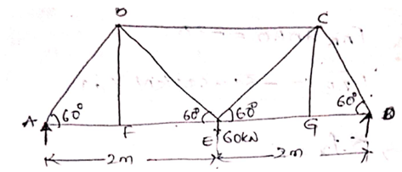 | L4 | CO1 | [8M]
 | OR
8 | Write the assumptions made in Analysis of pin jointed frame& write the method of analysis of frames | L2 | CO1 | [8M]
9. | Derive the expression for castiglianos threorem for unit load method | L3 | CO2 | [8M]
 | OR
10 | A symmentrical three hinged arch of span 20m and a rise of 4m carries a point load of 4KN at 4m span from left the left support calculate Normal thrust, Radial Shear and maximum bending moment | L4 | CO2 | [8M]
11. | A horizontal cantilever beam of span 6m long carries a udl of 5kn/m over a length of 2m from fixed end if the beam is propped at free end to the level of fixed end . find the loadf on the prop and draw the SF and BM | L5 | CO3 | [8M]
 | OR
12 | Derive the expression for a propped cantilever carrying uniformly distributed load | L5 | CO3 | [8M]
13 | Draw the SFD & BMD for the given beam using three moment method  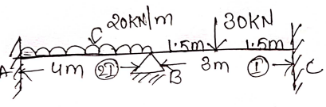 | L4 | CO4 | [8M]
 | OR
14 | Draw the SFD & BMD for the given beam using three moment method  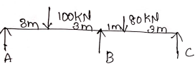 | L4 | CO4 | [8M]
15 | Draw the SFD & BMD for the given beam using slope deflection method  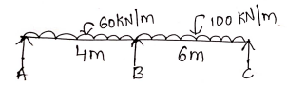c | L3 | CO5 | [8M]
 | OR
16 | Draw the SFD & BMD for the given beam using slope deflection method  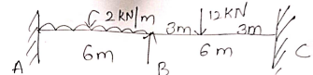 | L4 | CO5 | [8M]
17 | A simply supported beam of span 15m carries a udl of 40kn/m and 5m long crosses the grider from left to right . draw the influence line diagram for SF & BMat a section 6m from left support calculate max SF and maxBM | L5 | CO6 | [8M]
 | OR
18 | A udl of intensity 50kn/m and the length 6m carries a grider of span 25m from left to right calculate  1)Reaction  2)Max SF & max BM at a section 10m from left support  3) Absolute max BM | L4 | CO6 | [8M]

-- 00 -- 00 –

